Mission, Vision, and Values,
Guiding Statements

[Insert school name]

Delete and
replace with
school logo

Approved by: | [Name] | Date: [Date]
Last reviewed on: | [Date]
Next review due by: | [Date]

Our Mission
Orbital Education Group is one of the world’s leading UK-managed platforms of high-quality international schools. Its mission is to deliver an outstanding education via Internationally acclaimed schools.

All Orbital Education schools are unwavering in their commitment to deliver an international acclaimed education that reaches beyond academic achievement and excellent exam results, enabling students to access high-quality universities.

Each Orbital school is unique, defined by elements of their local culture and an international underpinning. But we are united in our aim to deliver an outstanding education. We build welcoming communities that celebrate diversity and enjoy a global outlook. Our students and employees are inspired, supported, and challenged every day to deliver on their ambitions and fulfil their potential.
To achieve this, we continually innovate and adapt so our schools offer the highest quality education, now and in future.

Our Vision
Orbital schools share common features, management principles, and policies aimed at ensuring the highest standards in all aspects of school life. These points of difference also distinguish Orbital schools from their competitors.
Curriculum and Learning
Students will be happy, safe, and challenged in their learning
All Orbital schools:
- embrace the opportunities offered by the host country, its language, culture, traditions and history. Schools are meaningfully members of their local community;
- celebrate and promote Global Internationalism. Students leave our schools ready to become members of a global community, well prepared for life in a rapidly changing world;
- value the native language and cultural identity of students’ family and, where possible, provide specialised instruction to allow pupils to develop their native language;
- recognise that most student are mastering at once the English language medium of the curriculum as well as its content. Assessment, support, and awareness of EAL needs are addressed throughout the phases;
- provide holistic educational experience that celebrates the unique talents and passions of individuals, developed through an extensive range of co-curricular activities;
- exploit the opportunities provided by digital technology, in particular, a virtual learning environment to promote an individualised approach to learning and to foster collaborative teaching and learning.
- are non-selective in the admission of students, but only students whose needs can be met by the school will be enrolled.

Students at Orbital schools develop good learning habits, a strong sense of responsibility, self-discipline and respect for others. Students are encouraged to reach the highest levels of achievement in their studies, and we celebrate and recognize their endeavours. Our students are expected to be courteous and respectful of others irrespective of gender, race, creed or nationality. While respecting the importance of their own culture, we aim to empower and prepare our students with the skills needed to contribute to, and be successful in, a global society. We believe that a partnership between students, teachers, administration, and parents will enable all individuals to become valued members of the school community, and global society.

How we deliver an outstanding education and measure ourselves against our promises.

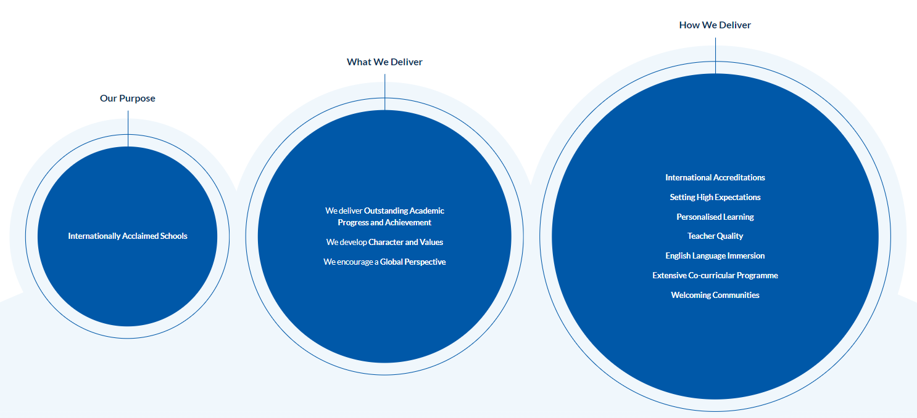

Our Values

Our five core values underpin everything we do. Sitting at the heart of our community of schools, they define how we work as a group and the characteristics our students and school teams demonstrate every day. Our values enable us to develop students who are valued members of their communities with the best intentions for themselves and others. Giving all our students the moral grounding to succeed and flourish during their school years and beyond.

- Excellence - We are ambitious, developing resilience, independence and a life-long love of learning.

- Respect - We celebrate diversity, encouraging respect for the people and the world around us.

- Responsibility - We are engaged, promoting actions and behaviours that support a sustainable future

- Integrity - We are transparent, honest, and ethical in all our relationships.

- Compassion - We are kind and caring, encouraging everyone to succeed.

Policy Review
These guiding statements should be reviewed, at least, every three years with due consultation including all stakeholders. The review and evaluation of the guiding statements may include qualitative and quantitative mechanisms providing data that informs the school’s direction and the Board in their strategic oversight of the school.
This policy is to be reviewed every three years.
This policy was updated/revised July 2024.
Next review date: July 2027
Reviewed: 2024

